Self-Serve Loan Onboarding SaaS Platform – Screen Wireframes & Flow Diagram
All user-facing screens across 4 phases · Customer · Bank Employee · Operations Team

PHASE 1 · CUSTOMER: SIGNUP & APPLICATION (SCREENS 1A – 1D)

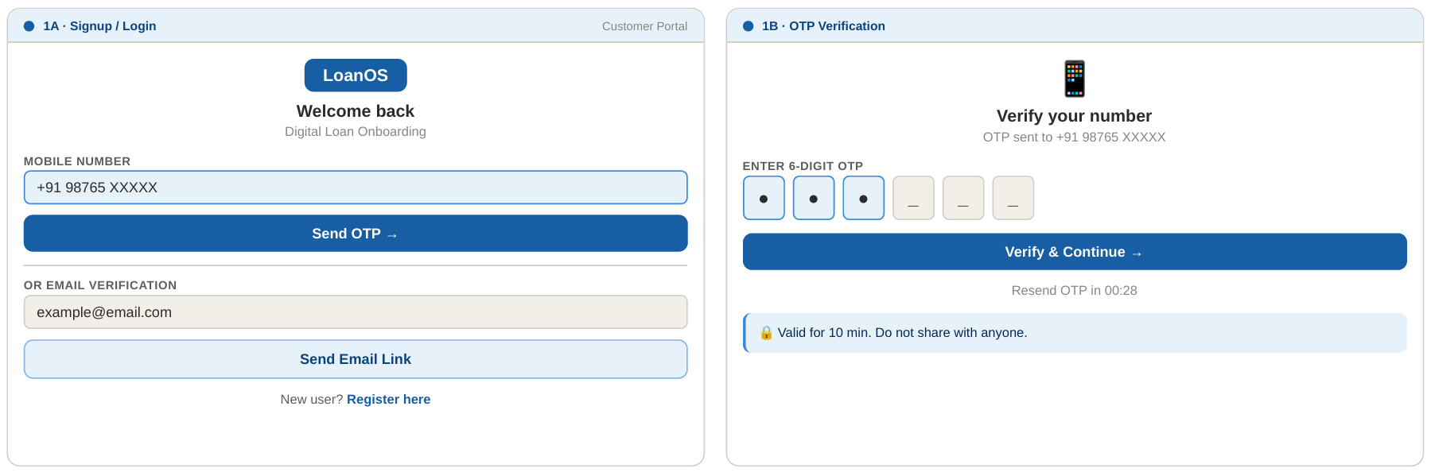
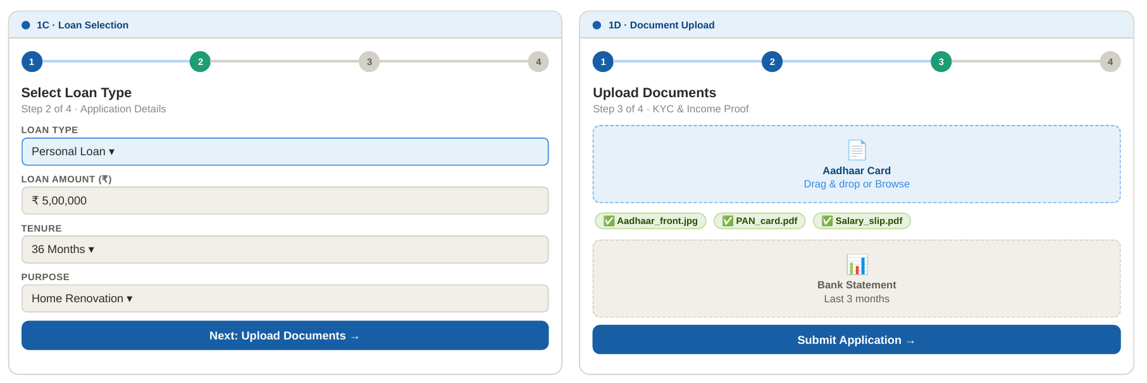
PHASE 2 · AUTOMATED VERIFICATION & CUSTOMER TRACKING (SCREENS 2A – 2D)
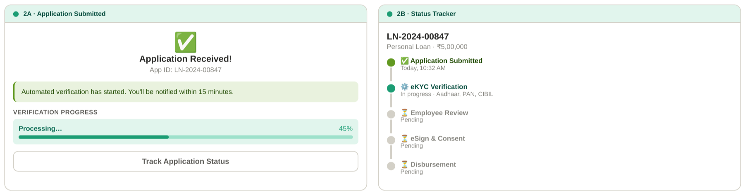
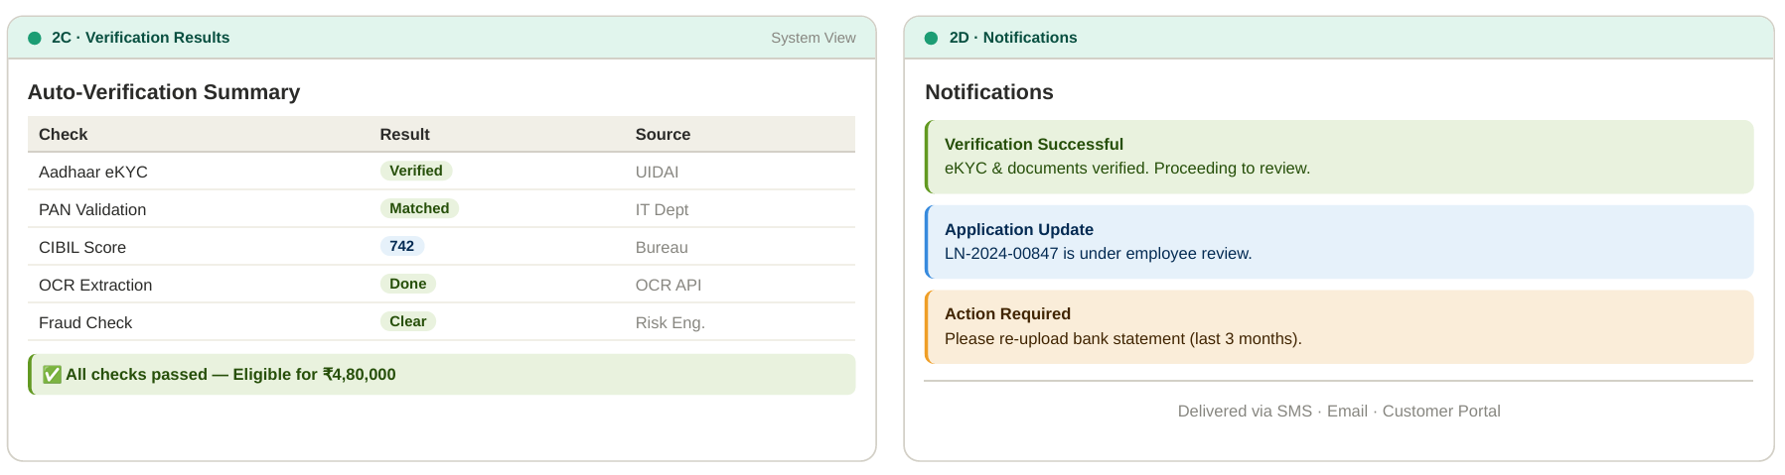
PHASE 3 · BANK EMPLOYEE REVIEW DASHBOARD (SCREENS 3A – 3B)
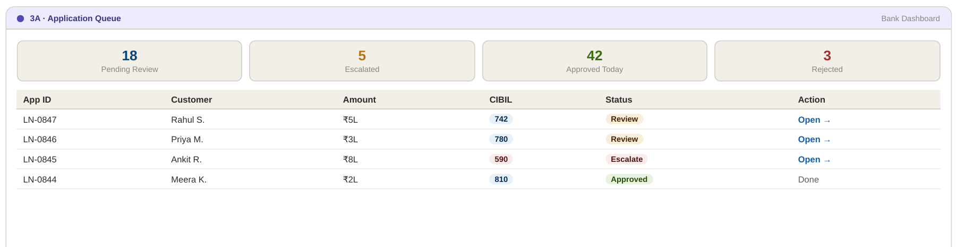
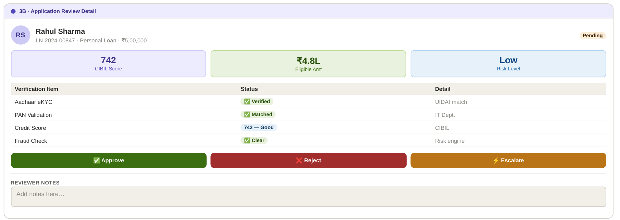
PHASE 4 · ESIGN · DISBURSEMENT · LOAN COMPLETION (SCREENS 4A – 4C)
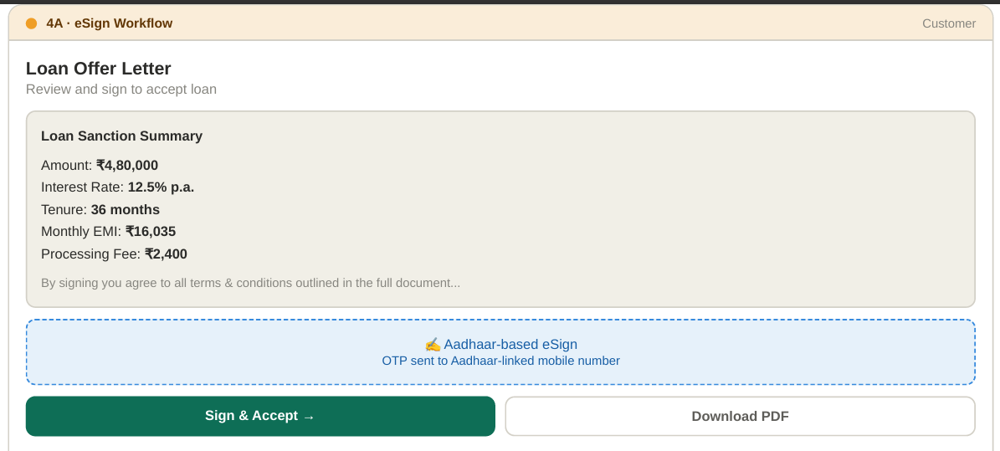

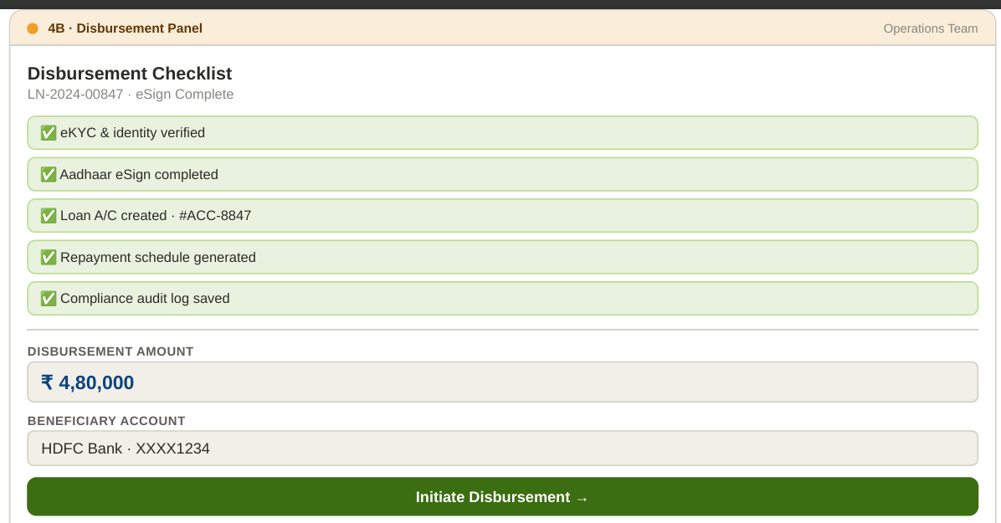
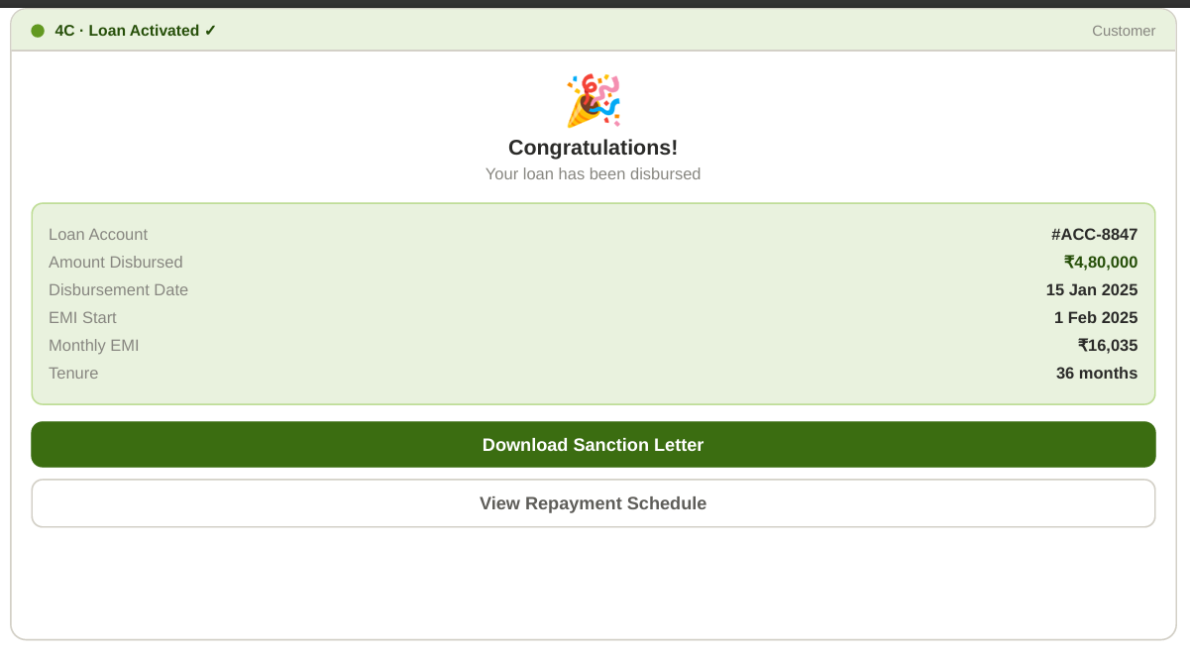
REFERENCE · USER ROLES SUMMARY & API INTEGRATIONS
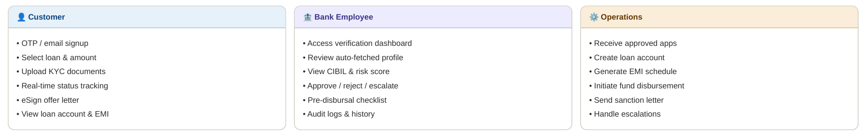
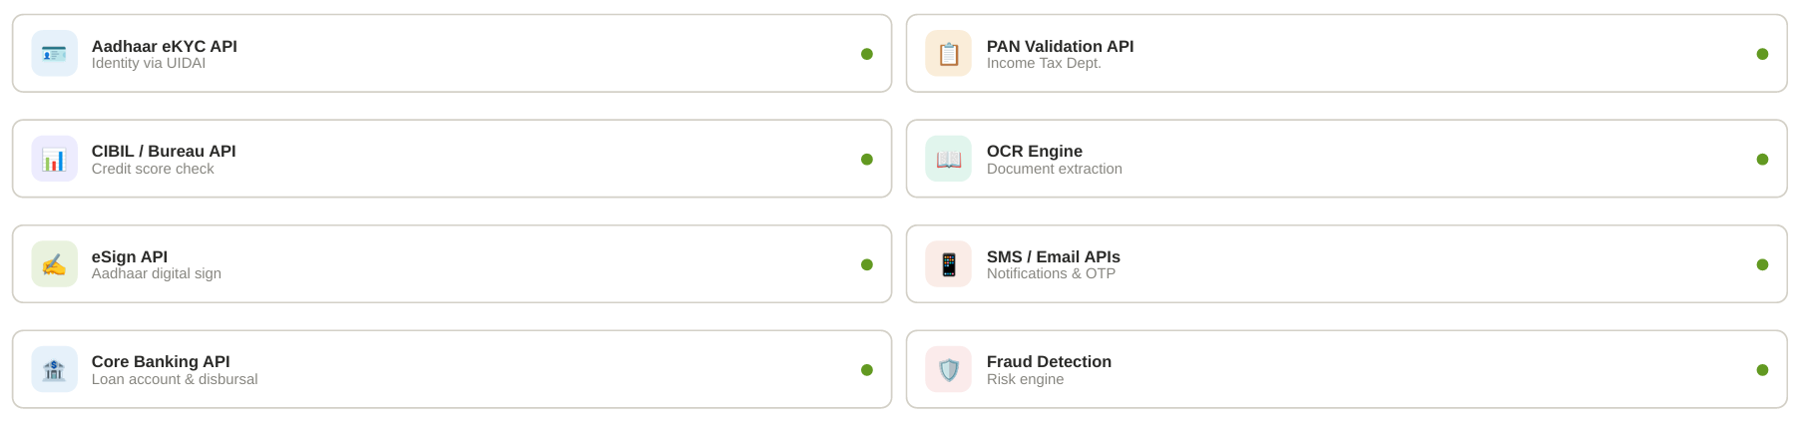
Strategic Process Flow
This flow maps the end-to-end journey from customer initiation to disbursement based on the PRD and Flow documents.
